August 2018

Dear Perry Community:

Perry’s Puma Parent Organization (PPO) of Perry High School is proud to announce its 11th annual “Taste of Perry”. This year we are again working with the Student Government and have combined the Taste with the PHS Carnival that is held during homecoming week! The Taste is at Perry High School on Thursday September 13, 2018 from 5:00pm to 7:00pm and everyone is welcome.

We are asking local businesses to participate in this event. We invite you to set up a food booth in the cafeteria so guests can sample your delicious food and/or desserts. This is a tremendous opportunity for you to show your Perry spirit and get additional exposure in our over 3,000 student strong community. This event is far-reaching and not limited to just the Perry faithful; the event will be advertised in the newspaper, social media and to all schools in the Chandler School District.

Please confirm your participation by September 5th so we can include you in the promotions. Please complete the following and return to PerryPumasPPO@gmail.com, along with the logo that you would like us to use in our marketing of this event. We look forward to hearing from you.

If you have any questions or concerns, please do not hesitate to give me a call.

Pamela LaBate
2018/2019 PPO President
Cell/text 480-250-0117
Email: PerryPumasPPO@gmail.com
Perry Pumas PPO
2018 Taste of Perry Reservation
Sept 13, 2018
(please complete and return to PerryPumasPPO@gmail.com by September 5th, 2018)

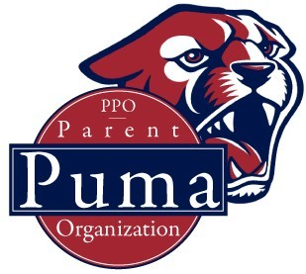
Contact Name___________________________________

Business________________________________________

Phone___________________________________________

Email____________________________________________

______ Yes, we will participate _________ No, sorry but not this year

PHS will provide tables, table clothes and volunteers if needed.
Please list food/dessert items you are planning:

Special Requests:

*The Maricopa Health Dept. Special Events Coordinator authorized this event if all vendors stay in the cafeteria and the food is donated and the event is run by our volunteers. The PPO provides washing stations.

